Replace and modernize legacy VPN architectures with a cloud-native Zscaler Zero Trust solution to reduce attack surface and lateral movement

Project Title:
Replace and modernize legacy VPN architectures with a cloud-native Zscaler Zero Trust solution to reduce attack surface and lateral movement.
Program: Naan Mudhalvan
Course : Cyber Security

Team Members:
Team Leader : AJITHA K
Team member : ATHINATH R
Team member : KARTHIKEYAN M
Team member : LOGANAYAKI A
Team member : MOHAMMED ANSARI M

Institution : SMS College of Arts and Science
Guide : K.PRIYADHARSHINI.,MSc., Mphil.,
Date :15.03.2026

Abstract:
Traditional Virtual Private Network (VPN) architectures are widely used by organizations to provide remote access to internal resources. However, legacy VPN solutions often expose large parts of the network, increasing the risk of cyberattacks, unauthorized access, and lateral movement by attackers. With the growing use of cloud services and remote work, these traditional security models are becoming less effective and harder to manage.
This project focuses on replacing legacy VPN infrastructure with a cloud-native Zero Trust security solution using Zscaler. The Zero Trust model operates on the principle of “never trust, always verify,” ensuring that users and devices are continuously authenticated and authorized before accessing applications or data. Unlike traditional VPNs that provide broad network access, the Zscaler platform enables secure, direct access to applications without exposing the internal network.
By implementing Zscaler Zero Trust architecture, organizations can significantly reduce their attack surface, prevent lateral movement of threats, and improve overall security posture. The cloud-based approach also simplifies network management, enhances scalability, and provides secure access for users working from any location.
This project highlights the benefits, architecture, and implementation strategy of transitioning from legacy VPN systems to a modern Zero Trust security framework using Zscaler technology.

Use Case Scenarios
Scenario 1. Remote Employee Secure Access
In many organizations, employees work remotely and need to access company applications and resources. Traditional VPN solutions allow users to connect directly to the internal network, which can expose the entire network to potential security threats.With the Zscaler Zero Trust solution, employees are authenticated and verified before accessing any application. Instead of providing full network access, users are only allowed to access specific applications they are authorized to use. This reduces the attack surface and improves security.
Scenario 2. Third-Party Vendor Access
Organizations often work with external vendors, partners, or contractors who require access to certain internal applications. Using a legacy VPN, these third parties may gain unnecessary access to the entire network.With Zero Trust architecture, vendors are given restricted access only to the specific applications they need. The internal network remains hidden and protected, ensuring sensitive data and systems are not exposed.
Scenario 3. Secure Access to Cloud Applications
Modern organizations use many cloud-based applications for business operations. In traditional VPN setups, users must first connect to the company’s data center before accessing cloud applications, which can cause delays and performance issues.
Zscaler provides direct and secure access to cloud applications through its cloud-native platform. This improves performance, reduces latency, and ensures secure communication between users and applications.
Scenario 4. Preventing Lateral Movement of Threats
If an attacker gains access to the network through compromised credentials in a VPN-based system, they may move across different systems inside the network.
Zero Trust architecture prevents this by limiting access only to specific applications rather than the entire network. Even if an attacker compromises a user account, they cannot move laterally across the organization’s systems.

STAGE – 1
Title of the project :
Replace and modernize legacy VPN architectures with a cloud-native Zscaler Zero Trust solution to reduce attack surface and lateral movement.
List of vulnerability :
- Credential Theft
Attackers may steal usernames and passwords through phishing or malware. If credentials are compromised, attackers can easily access the network through VPN.
- Excessive Network Access
Traditional VPNs often provide full network access once a user is connected, which increases the risk of unauthorized access to sensitive systems.
- Lateral Movement
After gaining access to the network, attackers can move from one system to another, spreading malware and compromising additional resources.
- Unpatched VPN Devices
VPN gateways and devices may have security vulnerabilities if they are not regularly updated or patched, making them easy targets for attackers.
- Lack of Device Verification
VPNs may allow access from insecure or infected devices without checking the device’s security posture.
- Phishing Attacks
Users can be tricked into revealing login credentials through phishing emails, enabling attackers to gain VPN access.
- Man-in-the-Middle Attacks
Attackers may intercept communication between the user and the VPN server, potentially stealing sensitive data.
- Limited Visibility and Monitoring
Traditional VPN solutions often lack advanced monitoring capabilities, making it difficult to detect suspicious activities in the network.
- Single Point of Failure
VPN concentrators or gateways can become a single point of failure. If they are attacked or overloaded, the entire network access can be disrupted.
- Increased Attack Surface
VPNs expose parts of the internal network to the internet, increasing the chances of cyberattacks.
- Weak Authentication Mechanisms
Many legacy VPN systems rely only on username and password authentication. Without strong authentication methods such as multi-factor authentication (MFA), attackers can easily gain access.
- Brute Force Attacks
Attackers may attempt multiple login attempts using automated tools to guess user credentials and gain unauthorized VPN access
- Insider Threats
Employees or internal users with VPN access may intentionally or unintentionally misuse their privileges, leading to data leakage or system compromise.
- Poor Access Control Policies
Legacy VPN systems may not enforce strict access control policies, allowing users to access more resources than necessary.
- Network Exposure
VPNs expose internal network infrastructure to external users, which increases the chances of cyberattacks targeting internal services.

List of teammates
S.no | name | collage | contact
1. | Ajitha K | SMS College of Arts & Science | 6382235198
2. | Athinath R | SMS College of Arts & Science | 9943752300
3. | Karthigeyan M | SMS College of Arts & Science | 9003107609
4. | Loganayagi A | SMS College of Arts & Science | 9597422425
5. | Mohammed Ansari M | SMS College of Arts & Science | 8754153251

REPORT:
Vulnerability Name:- Absolute Path Traversal
CWE/CVE : - CWE-36
OWASP/SANS Category:- A01:2025 Broken Access Control
Description:-
Absolute Path Traversal is a vulnerability that allows attackers to access files and directories outside the intended folder of a web application. This occurs when user input used in file paths is not properly validated. By manipulating the file path, an attacker can access sensitive files such as system configurations, application code, or confidential data. Proper input validation and restricting file access can help prevent this vulnerability.
Business Impact::-
Absolute Path Traversal can have serious consequences for an organization. If exploited, attackers may gain unauthorized access to sensitive files such as system configurations, application source code, or confidential business data. This can lead to data breaches, exposure of internal information, system compromise, and loss of customer trust. In severe cases, it may also result in financial losses, legal penalties, and damage to the organization’s reputation. Proper security controls and input validation are necessary to reduce this risk
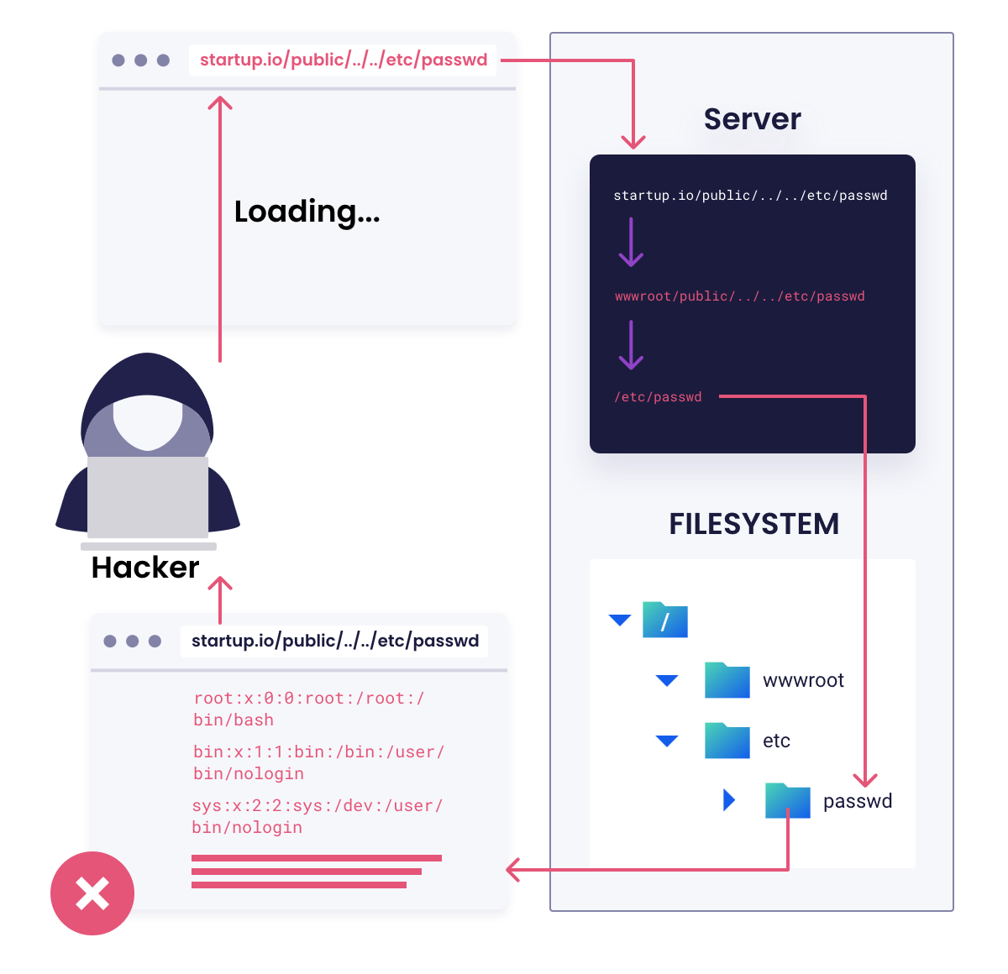
Vulnerability Name:- SQL Injection
CWE/CVE : - CWE-89
OWASP/SANS Category:- A03:2025 Injection
Description:-
SQL Injection is a web security vulnerability that occurs when an application fails to properly validate user input used in SQL queries. Attackers can insert malicious SQL statements into input fields such as login forms or search boxes. This can allow attackers to bypass authentication, access sensitive data, modify database records, or delete critical information.
Business Impact:
If exploited, SQL Injection can expose confidential information such as customer records, financial data, and login credentials. Attackers may also modify or delete important business data, causing service disruption. In severe cases, the entire database system may be compromised, resulting in financial losses, legal consequences, and damage to the organization’s reputation.
.

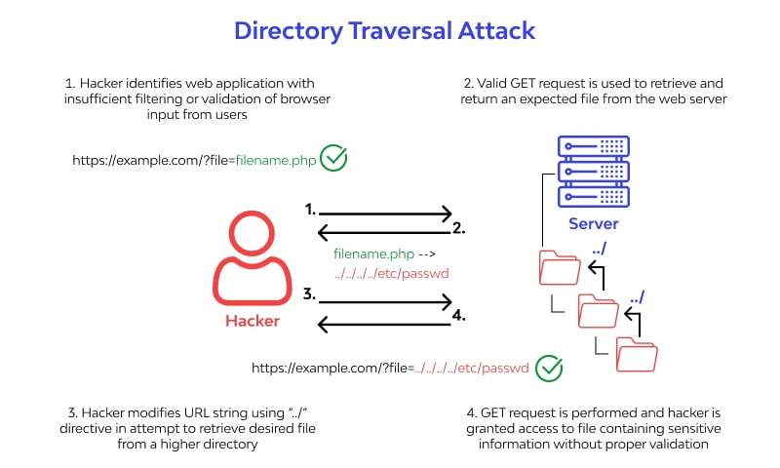
Vulnerability Name:- Cross-Site Request Forgery (CSRF)
CWE/CVE : - CWE-352
OWASP/SANS Category:- A01:2025 Broken Access Control
Description:-
Cross-Site Request Forgery (CSRF) is a vulnerability that forces an authenticated user to perform unwanted actions on a web application. Attackers trick users into clicking a malicious link or visiting a malicious website that sends unauthorized requests to another website where the user is already authenticated. This happens when the application does not properly validate the request source.
Business Impact:
If exploited, attackers can perform actions such as changing account details, transferring funds, or modifying data without the user's knowledge. This can lead to financial loss, unauthorized transactions, data manipulation, and damage to the organization's reputation.
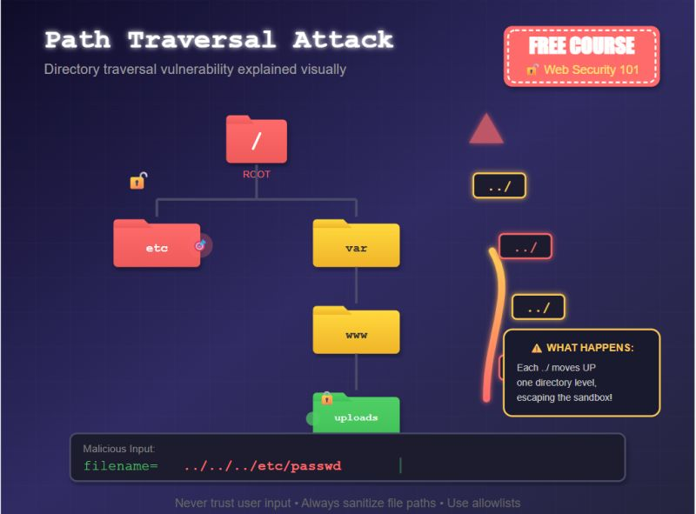

STAGE 2
1. Tool Used
In this project, Nessus was used to identify security weaknesses in the network and systems. Nessus is a widely used vulnerability assessment tool that helps security professionals detect vulnerabilities, misconfigurations, and outdated software in servers, applications, and network devices.
2. Purpose of Using Nessus
The main purpose of using Nessus in this project is:
- To identify vulnerabilities in legacy VPN infrastructure
- To detect security misconfigurations in the network
- To discover weaknesses that attackers could exploit
- To perform security assessment before implementing a Zero Trust architecture
3. Installation of Nessus
Steps for installing Nessus:
- Download Nessus Essentials from the official website of Tenable.
- Install the software on the system.
- Access the Nessus web interface through a browser.
- Activate the tool using the license key.
4. Scanning Process
Steps involved in performing vulnerability scanning using Nessus:
- Open the Nessus dashboard.
- Click on the New Scan option.
- Select Basic Network Scan template.
- Enter the target IP address or network range.
- Start the scan process.
- After completion, Nessus generates a detailed vulnerability report.
5. Types of Vulnerabilities Detected
The scan can detect different types of vulnerabilities such as:
- Absolute Path Traversal
- Outdated Software Versions
- Open Ports and Services
- Weak SSL/TLS Configuration
- Missing Security Patches
These vulnerabilities may allow attackers to gain unauthorized access to systems.
6. Risk Levels in Nessus
Nessus categorizes vulnerabilities based on severity levels:
Severity | Description
Critical | Very dangerous vulnerability that must be fixed immediately
High | Serious security risk
Medium | Moderate vulnerability
Low | Minor security issue
Informational | No direct risk but useful information
7. Benefits of Using Nessus
- Identifies security vulnerabilities in networks and systems
- Helps improve overall security posture
- Prioritizes risks based on severity
- Supports compliance and security standards
- Assists in securing environments before implementing Zero Trust Architecture

List of Vulnerabilities:
- Absolute Path Traversal (CWE-36)
Allows attackers to access files and directories outside the intended directory of a web application.
- SQL Injection (CWE-89)
Attackers can manipulate database queries to access, modify, or delete sensitive data.
- Cross-Site Scripting – XSS (CWE-79)
Allows attackers to inject malicious scripts into web pages viewed by other users.
- Open Ports and Services
Unnecessary open ports may allow attackers to discover and exploit running services.
- Outdated Software Versions
Old versions of software may contain known vulnerabilities that attackers can exploit.
- Weak SSL/TLS Configuration
Improper SSL/TLS settings may expose encrypted communication to attacks.
- Missing Security Patches
Systems that are not updated regularly may have vulnerabilities that are already known and exploitable.
- Default Credentials
Systems using default usernames and passwords can easily be accessed by attackers.
- Sensitive Information Disclosure
Sensitive information such as system paths, configuration files, or database details may be exposed.
- Directory Listing Enabled
Allows attackers to view files and folders on a server that should normally be hidden.
- Remote Code Execution (RCE)
Allows attackers to run arbitrary code on a vulnerable system.
- Denial of Service (DoS)
Attackers may exploit vulnerabilities to crash a system or make services unavailable.
- Weak Password Policy
Poor password complexity requirements increase the risk of brute-force attacks.
- Improper Access Control
Unauthorized users may access restricted resources.
- Unencrypted Communication
Data transmitted without encryption can be intercepted by attackers.

STAGE 3

REPORT:
Title: Replace and modernize legacy VPN architectures with a cloud-native Zscaler Zero Trust solution to reduce attack surface and lateral movement..
Ability of SOC / SIEM
1. Security Monitoring
Ability to continuously monitor network traffic, system logs, and security alerts using Splunk or IBM QRadar to detect suspicious activities.
2. Threat Detection
Ability to identify potential cyber threats, malware attacks, and unauthorized access attempts from security logs.
3. Log Analysis
Ability to analyze large volumes of logs from servers, firewalls, and applications to identify abnormal behavior.
4. Incident Response
Ability to quickly respond to security incidents, investigate the cause, and take action to reduce damage.
5. Alert Management
Ability to handle and prioritize security alerts generated by SIEM tools.
6. Vulnerability Management
Ability to identify and manage vulnerabilities using tools like Nessus.
7. Threat Intelligence
Ability to use threat intelligence data to identify new cyber threats and attack patterns.
8. Security Reporting
Ability to generate security reports and communicate findings to management and security teams.
9. Network Security Knowledge
Understanding of firewalls, IDS/IPS, VPN, and network security concepts.
10. Continuous Improvement
Ability to update detection rules and improve security monitoring to protect the organization.
SOC (Security Operations Center)
A Security Operations Center is a centralized team responsible for continuously monitoring, detecting, analyzing, and responding to cybersecurity incidents within an organization. The SOC team protects the organization’s network, systems, and data from cyber threats.

SOC Cycle
The Security Operations Center cycle describes the process used by SOC teams to detect, analyze, and respond to cybersecurity threats. It ensures continuous monitoring and protection of an organization’s network and systems.
SIEM (Security Information and Event Management)
Security Information and Event Management is an advanced cybersecurity solution used by organizations to monitor, detect, analyze, and respond to security threats in real time. SIEM systems collect security data from various devices and applications across the network and analyze this information to identify suspicious activities, potential cyber attacks, and security policy violations.SIEM plays a very important role in modern cybersecurity environments because organizations generate large volumes of security logs every day. It becomes difficult for security teams to manually analyze these logs. SIEM tools automate this process by collecting and correlating logs from multiple sources and providing real-time visibility into security events. This helps security teams detect threats early and respond quickly before serious damage occurs.
SIEM Cycle
The Security Information and Event Management cycle describes the continuous process used to collect, analyze, and respond to security events in an organization’s network. This cycle helps security teams detect cyber threats quickly and take appropriate action to protect systems and data.
MISP (Malware Information Sharing Platform)
MISP is an open-source threat intelligence platform used by organizations to collect, store, share, and analyze information about cyber threats. It helps security teams collaborate and exchange threat intelligence data to detect and prevent cyber attacks more effectively.MISP is widely used by cybersecurity teams, government agencies, and organizations to share information about malware, attack patterns, malicious IP addresses, and other indicators of compromise (IOCs). By sharing this information, organizations can strengthen their defenses and respond quickly to new threats.
Your College Network Information
The college network infrastructure is designed to provide secure and reliable connectivity for students, faculty, and administrative staff. The network supports various academic and administrative activities such as online learning, research, email communication, and access to institutional resources.
The network consists of multiple devices including routers, switches, servers, and wireless access points. These devices are interconnected to form a local area network (LAN) that allows users within the campus to access shared resources such as printers, file servers, and internet services.
The college network is connected to the internet through a high-speed broadband connection provided by an Internet Service Provider. Network security measures such as firewalls, antivirus systems, and monitoring tools are implemented to protect the network from unauthorized access and cyber threats.
For security monitoring and threat detection, cybersecurity tools such as Splunk and MISP can be used to analyze logs and detect suspicious activities. These tools help in identifying potential threats and improving the overall security of the college network.
The network is managed by the college IT department, which is responsible for maintaining network performance, managing user access, updating security systems, and ensuring the continuous availability of network services.

How You Think You Deploy SOC in Your College (Extended)
To deploy a Security Operations Center (SOC) in our college, the first step is to establish a centralized monitoring system that collects security data from different parts of the campus network. This includes servers, routers, switches, firewall devices, Wi-Fi networks, and computer lab systems. All logs generated by these devices will be forwarded to a centralized SIEM platform where they can be analyzed in real time.The SOC team would monitor the alerts generated by the SIEM tool and investigate any suspicious activities such as multiple failed login attempts, unusual data transfers, or malware detection. Security policies such as user authentication, access control, and network segmentation would also be implemented to protect sensitive systems like student records, examination databases, and administrative portals. By implementing SOC in the college environment, the institution can continuously monitor network security and respond quickly to cyber threats.
Threat Intelligence (Extended)
Threat intelligence plays a critical role in improving cybersecurity defenses by providing information about current and emerging cyber threats. It involves collecting, analyzing, and sharing information related to malicious activities such as malware attacks, phishing campaigns, and vulnerability exploitation.In a college environment, threat intelligence can help the IT team understand the types of attacks that commonly target educational institutions. By using threat intelligence feeds, the SOC team can update firewall rules, block malicious IP addresses, and strengthen system security. Threat intelligence also helps in predicting potential attacks and preparing preventive measures, ensuring that the college network remains protected from external cyber threats.
Incident Response (Extended)
Incident response is a structured approach used to handle cybersecurity incidents efficiently. The process usually includes several stages such as detection, analysis, containment, eradication, and recovery. When a security alert is generated, the SOC team first analyzes the event to determine whether it is a real threat or a false alarm.
If the incident is confirmed, the affected systems are isolated to prevent the threat from spreading across the network. After containment, the security team removes the malicious elements such as malware or unauthorized access points. Finally, the systems are restored to normal operation and security improvements are implemented. Proper incident response ensures that cyber incidents are handled quickly and that the college network remains secure and operational.
IBM QRadar – Understanding About the Tool (Extended)
IBM QRadar is a widely used SIEM tool designed to detect and analyze security threats across an organization’s IT infrastructure. It collects log and event data from various sources including servers, network devices, applications, and security tools. QRadar uses advanced analytics and correlation rules to identify suspicious patterns that may indicate cyber attacks.
The tool provides a centralized dashboard where security analysts can monitor network activities and investigate alerts. QRadar also prioritizes security incidents based on their severity, allowing analysts to focus on the most critical threats first. In a college SOC environment, QRadar can help track unauthorized login attempts, detect malware activity, and monitor network traffic. This improves the ability of the IT team to quickly identify and respond to potential security threats.

Conclusion
In this project, the traditional legacy VPN architecture was analyzed and improved by implementing a cloud-native Zero Trust security model. The objective of this project was to reduce the attack surface, prevent unauthorized access, and limit lateral movement inside the network environment.
By adopting the Zero Trust approach provided by Zscaler, organizations can ensure that every user and device is verified before accessing network resources. This approach eliminates the security risks associated with traditional VPN systems and provides better control over user access.
Security monitoring and threat detection were also enhanced using technologies such as Security Information and Event Management, which helps collect and analyze security logs in real time. Tools like Nessus were used to identify vulnerabilities in the system, while threat intelligence platforms such as MISP help organizations share and analyze cyber threat information.
Overall, this project demonstrates how modern cloud-based security solutions combined with advanced monitoring and vulnerability management can significantly improve network security. Implementing Zero Trust architecture helps organizations build a more secure, scalable, and resilient IT infrastructure capable of defending against modern cyber threats.
Future Scope
The future scope of this project focuses on improving network security by implementing advanced cybersecurity technologies and automation. As cyber threats continue to evolve, organizations must adopt modern security frameworks and intelligent monitoring systems to protect their infrastructure.
In the future, the system can be enhanced by integrating more advanced Zero Trust security models using platforms such as Zscaler, which provide secure access to applications without relying on traditional VPN architectures. This will further reduce the attack surface and prevent unauthorized access to sensitive resources.
Another improvement can be the deeper integration of Security Information and Event Management platforms to enable real-time monitoring and automated threat detection. SIEM tools such as Splunk can analyze large volumes of security logs and identify abnormal behavior quickly.
Future development can also include advanced vulnerability management using tools like Nessus to continuously scan and detect security weaknesses in the network. This will help organizations fix vulnerabilities before attackers can exploit them.
Additionally, the system can integrate threat intelligence platforms such as MISP to share information about emerging cyber threats. This collaboration can help organizations respond faster to new attack techniques.
Artificial intelligence and machine learning technologies may also be incorporated in the future to improve threat detection, automate incident response, and reduce the workload of security analysts in a Security Operations Center.
Overall, the future development of this project can lead to a more intelligent, automated, and highly secure network environment that can effectively defend against advanced cyber threats.

Topics Explored
In this project, several important cybersecurity technologies and concepts were explored to understand how modern security solutions can replace traditional VPN-based network architectures.
One of the main topics explored was the concept of Zero Trust security architecture implemented through Zscaler. This model ensures that every user and device must be verified before accessing network resources, which helps reduce unauthorized access and limits lateral movement within the network.
Another important topic studied in this project was Security Information and Event Management. SIEM systems collect and analyze security logs from multiple sources to detect suspicious activities and potential cyber attacks in real time. Popular SIEM tools such as Splunk were explored to understand how organizations monitor and manage security events.
The project also examined vulnerability assessment using Nessus. This tool helps identify security weaknesses, outdated software, and misconfigurations that attackers may exploit. Vulnerability scanning plays an important role in strengthening the security posture of an organization.
Another key area explored was threat intelligence sharing using MISP. This platform enables organizations to share information about cyber threats, malware indicators, and attack techniques, helping security teams detect and respond to threats more effectively.
In addition, the project explored the role of a Security Operations Center, which is responsible for continuously monitoring security events, investigating incidents, and responding to cyber threats.
Overall, the project covered multiple cybersecurity domains including Zero Trust architecture, vulnerability assessment, threat intelligence, and security monitoring. These topics collectively help organizations build a stronger and more secure network environment.

Tools Explored
In this project, several cybersecurity tools and platforms were explored to understand how organizations monitor, detect, and prevent cyber threats. These tools help improve network security, identify vulnerabilities, and support modern security architectures.
One of the main tools explored in this project is Zscaler, which provides a cloud-native Zero Trust security platform. Zscaler helps organizations replace traditional VPN architectures and ensures secure access to applications by verifying users and devices before granting access.
Another important tool explored is Nessus, which is widely used for vulnerability assessment. Nessus scans systems, networks, and applications to identify security weaknesses such as outdated software, open ports, and configuration issues.
The project also explored Security Information and Event Management tools used for centralized security monitoring. SIEM platforms collect and analyze logs from different systems to detect suspicious activities and potential cyber attacks. A commonly used SIEM tool studied in this project is Splunk, which provides real-time log analysis and threat detection.
Another tool explored is MISP, which is a threat intelligence platform used for sharing and managing information about cyber threats. MISP helps organizations exchange indicators of compromise and improve their ability to detect and respond to attacks.
These tools play a crucial role in the operations of a Security Operations Center, where security analysts monitor systems, investigate alerts, and respond to potential security incidents.
Overall, the tools explored in this project provide a comprehensive understanding of modern cybersecurity practices including vulnerability assessment, threat intelligence sharing, security monitoring, and Zero Trust access control.

